Operate with Turtlebot2

When you read this tutorial we assume that you have already installed ROS and read the General lessons!

Starting turtlebot2 in Gazebo simulation
Open new terminal and enter the command:
roslaunch turtlebot_gazebo turtlebot_world.launch

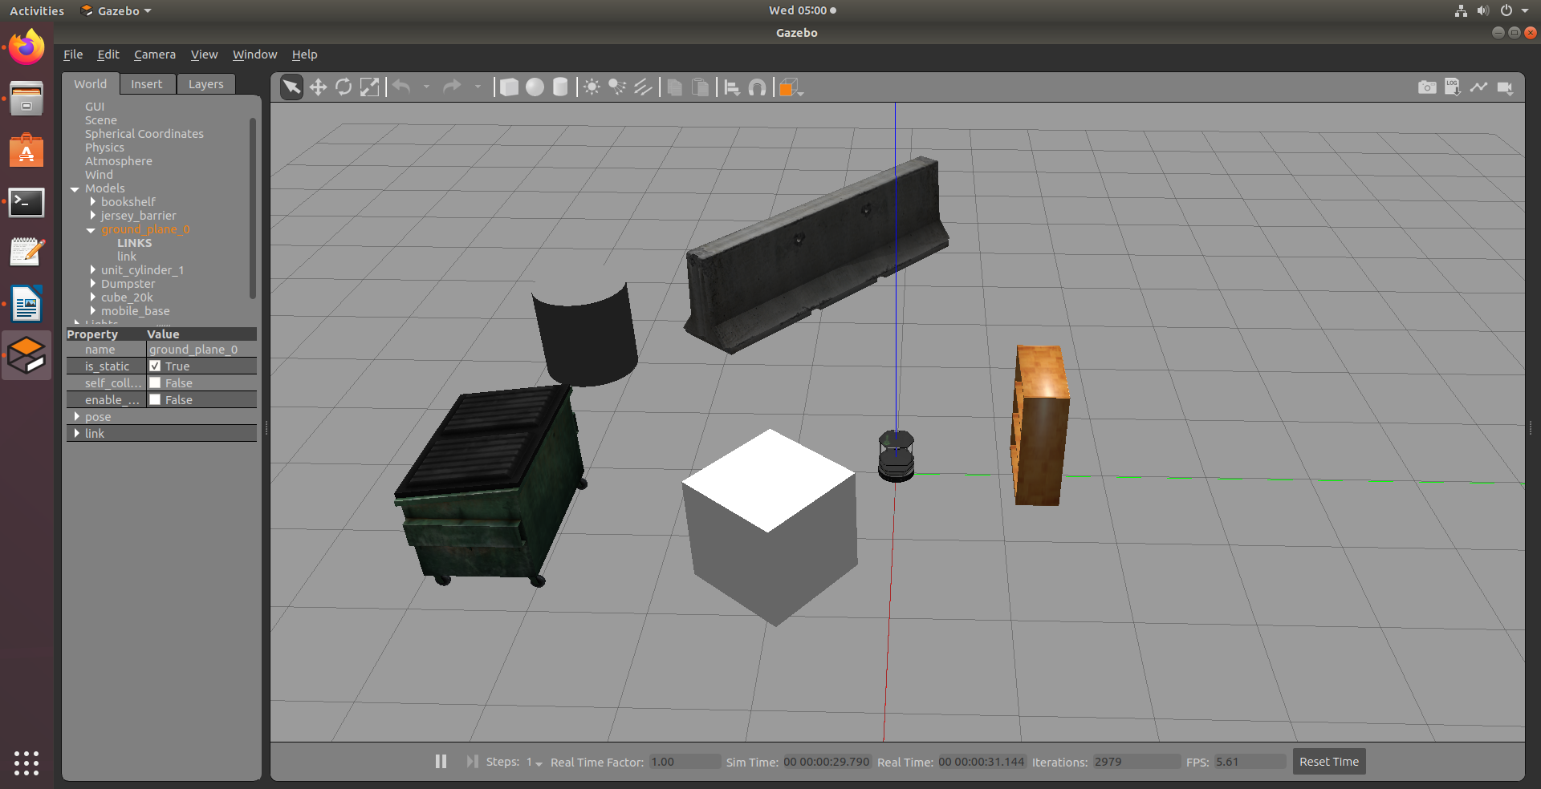

Move the robot in the simulation
In order to teleoperate the Turtlebot2 robot with the keyboard, launch the teleoperation node with below command in a new terminal window. This terminal must be active if you want to send commands.
roslaunch turtlebot_teleop keyboard_teleop.launch

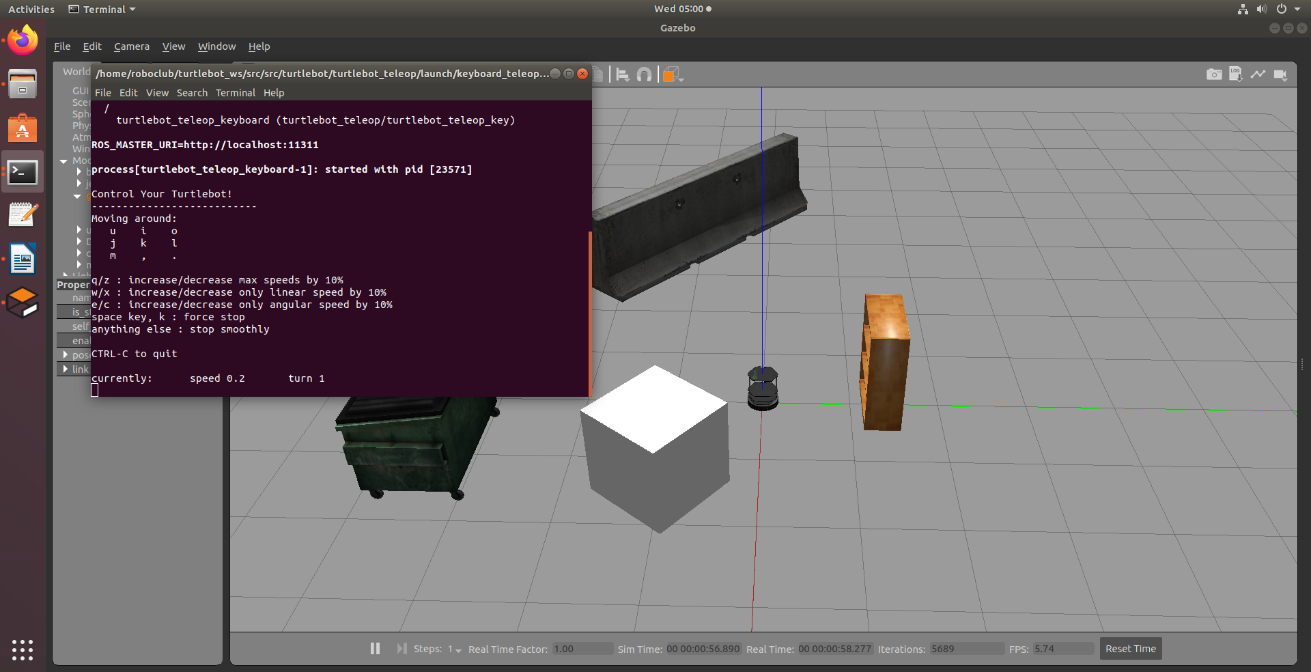

To terminate the teleop node enter the Ctrl+C in the terminal that run that node.

Turtlebot2 Gmapping demo:
In four separate terminal windows:

Chose depth sensor and Start the Turtlebot2 simulation environment:
export TURTLEBOT_3D_SENSOR=asus_xtion_pro
roslaunch turtlebot_gazebo turtlebot_world.launch

Start the gmapping demo:
roslaunch turtlebot_navigation gmapping_demo.launch

Start the rviz visualizer:
roslaunch turtlebot_rviz_launchers view_navigation.launch

Start the teleop node:
roslaunch turtlebot_teleop keyboard_teleop.launch

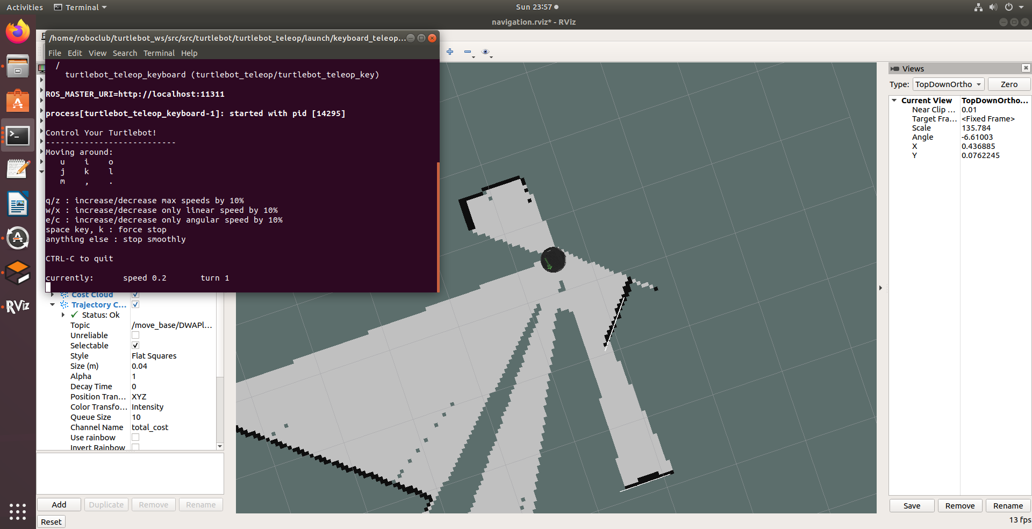

To save the generated map, you can run the map_saver utility in new terminal:

rosrun map_server map_saver -f ~/turtlebot2_map

Turtlebot2 Navigation demo:
In three separate terminal windows:
- Start the Turtlebot2 simulation environment:
export TURTLEBOT_3D_SENSOR=asus_xtion_pro
roslaunch turtlebot_gazebo turtlebot_world.launch

- Start the turtlebot2 navigation:
roslaunch turtlebot_navigation amcl_demo.launch map_file:=$HOME/turtlebot2_map.yaml

- Start the rviz visualizer:
roslaunch turtlebot_rviz_launchers view_navigation.launch

- Estimate Initial Pose
Initial Pose Estimation must be performed before running the Navigation as this process initializes the AMCL parameters that are critical in Navigation. TurtleBot3 has to be correctly located on the map with the LDS sensor data that neatly overlaps the displayed map.

- Click the 2D Pose Estimate button in the RViz menu.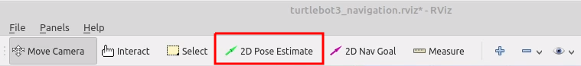
- Click on the map where the actual robot is located and drag the large green arrow toward the direction where the robot is facing.
- Repeat step 1 and 2 until the LDS sensor data is overlayed on the saved map.

- Set Navigation Goal
- Click the 2D Nav Goal button in the RViz menu.
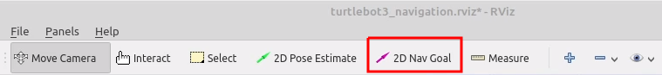
- Click on the map to set the destination of the robot and drag the green arrow toward the direction where the robot will be facing.

